[Statistical Methods for Decision Making](https://olympus.mygreatlearning.com/courses/104289" \t ")

## BUSINESS REPORT

BY: - ABHISHEK K HIREMATH

|  |  |
| --- | --- |
| **Content** | **Page** |
| **Problem 1** | 03-20 |
| A. What is the important technical information about the dataset that a database administrator would be interested in? (Hint: Information about the size of the dataset and the nature of the variables) | 3-4 |
| B. Take a critical look at the data and do a preliminary analysis of the variables. Do a quality check of the data so that the variables are consistent. Are there any discrepancies present in the data? If yes, perform preliminary treatment of data. | 5-8 |
| C. Explore all the features of the data separately by using appropriate visualizations and draw insights that can be utilized by the business. | 8-9 |
| D. Understanding the relationships among the variables in the dataset is crucial for every analytical project. Perform analysis on the data fields to gain deeper insights. Comment on your understanding of the data. | 10-13 |
| E. Employees working on the existing marketing campaign have made the following remarks. Based on the data and your analysis state whether you agree or disagree with their observations. Justify your answer Based on the data available.  **E1) “**Do men tend to prefer SUVs more compared to women?**”**  **E2)** What is the likelihood of a **salaried** person buying a **Sedan**?  **E3)** What evidence or data supports **Sheldon Cooper's claim** that a salaried male is an easier target for a **SUV** sale over a Sedan sale?  **E4)** How does the amount spent on purchasing automobiles vary by **Gender?**  **E5)** How much money was spent on purchasing automobiles by **individuals** who took a **personal loan**?  **E6)** How does having a **working partner** influence the purchase of higher-priced cars? | 15-18 |
| F. From the given data, comment on the amount spent on purchasing automobiles across the following categories. Comment on how a business can utilize the results from this exercise. Give justification along with presenting metrics/charts used for arriving at the conclusions. | 18 |
| G. The main objective of this analysis is to devise an improved marketing strategy to send targeted information to different groups of potential buyers present in the data. For the current analysis use the Gender and Marital status - fields to arrive at groups with similar purchase history. | 19 |
| **H.** Actionable Insights – Business Recommendation | 20 |
| **Problem 2** | 20-25 |
| Analyze the dataset and list down the top 5 important variables, along with the business justifications. | 25 |

**Problem-1: Austo Motors**

**Austo Motor Company is a leading car manufacturer specializing in SUV, Sedan, and Hatchback models. In its recent board meeting, concerns were raised by the members on the efficiency of the marketing campaign currently being used. The board decides to rope in an analytic professional to improve the existing campaign.**

Here is the dataset - [Link](https://olympus.mygreatlearning.com/courses/87091/files/7283021/download?verifier=D7dUkEA55E9I7udmucuVDJwWyscmRlirUlqSRaeI&wrap=1)

**A.What is the important technical information about the dataset that the database administrator would be interested in? (Hint: Information about size of the dataset and the nature of the variables**

* Size of Dataset: Dataset has 1581 rows and 14 columns.
* Data head & Data Tail: the dataset for quick reference.

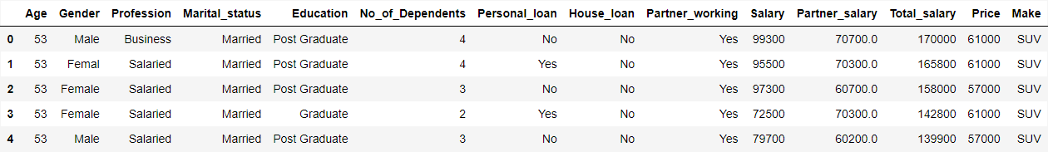

**Fig: -1**

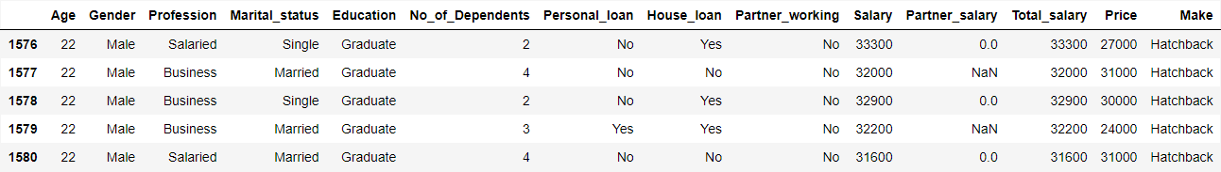

**Fig: -2**

here are the some refrence of dataset.

* Dataset Information**:** There are 6 numerical and 8 categorical variables. The details of each:

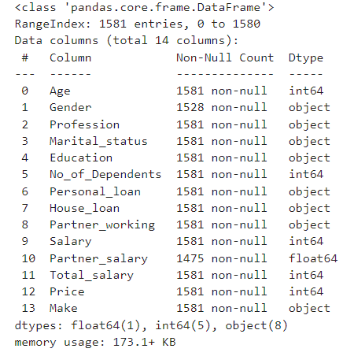

**fig: -3**

**B.Take a critical look at the data and do a preliminary analysis of the variables. Do a quality check of the data so that the variables are consistent. Are there any discrepancies present in the data? If yes, perform preliminary treatment of data.**

**Inspecting Missing Values:** There are Null records present in two variables: Gender and Partner salary.

Gender – total 53 Nulls, Partner salary – Total 106 Nulls

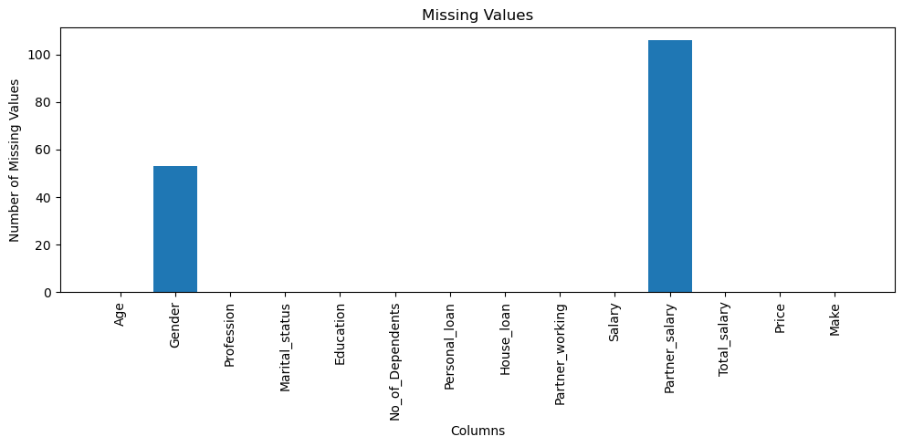

**Fig: -4**  **fig: -5**

**Treating the Null values: -**

1. **Gender:** Null values in Gender field can be imputed with ‘**Male’** having as the **mode** (maximum value in the dataset)
2. **Partner salary: fillna():** represent missing data, This is a method that replaces NaN (Not a Number) values with the value you provide. NaN values are often used in pandas to represent the missing data.

The Data Frame df, replace all the NaN values in the Partner salary column with the mean salary of the partners, and make this change in the original Data Frame”. This is a common way to handle missing data in datasets.

**Duplicate Values**: There are **no duplicate** records in the dataset.

**Bad Values**: Bad values are present in Gender as **Femal** , **Femle** and **nan** Rest of the categorical fields seem to be fine.

Array([‘Male’, ‘Femal’, ‘Female’, nan, ‘Femle’], dtype=object)

We will be treating the above by **replacing** the values Femal or Femle with **Female** and **nan** values with **male**.

Array ([‘Male’, ‘Female’], dtype=object)

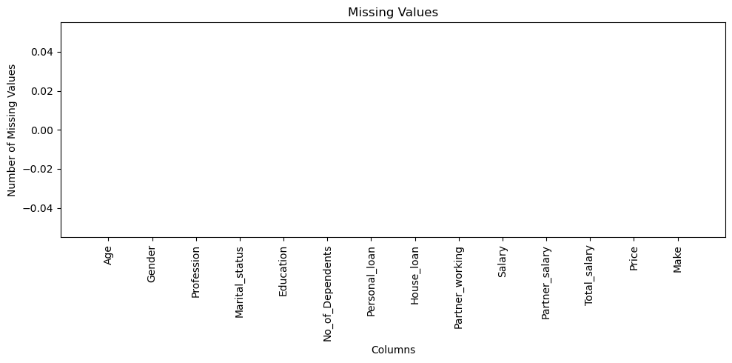

**Fig: -5**

**Inspecting the Summary Statistics of the Dataset**

|  | **count** | **unique** | **top** | **freq** |
| --- | --- | --- | --- | --- |
| Gender | **1581** | **2** | **Male** | **1252** |
| Profession | **1581** | **2** | **Salaried** | **896** |
| Marital status | **1581** | **2** | **Married** | **1443** |
| Education | **1581** | **2** | **Post Graduate** | **985** |
| Personal loan | **1581** | **2** | **Yes** | **792** |
| House loan | **1581** | **2** | **No** | **1054** |
| Partner working | **1581** | **2** | **Yes** | **868** |
| Make | **1581** | **3** | **Sedan** | **702** |
| Gender Marital status | **1581** | **4** | **Male, Married** | **1136** |

**Fig: -6**

division

Binary Multilevel

Gender Make

Personal_loan Education

Marital_status Profession

House_loan

Partner_working

division

Binary Multilevel

Gender Make

Personal_loan Education

Marital_status Profession

House_loan

Partner_working

Binary Multilevel

Gender Make

Personal_loan Education

Marital_status Profession

House_loan

Partner_working

|  | **count** | **mean** | **std** | **min** | **25%** | **50%** | **75%** | **max** |
| --- | --- | --- | --- | --- | --- | --- | --- | --- |
| **Age** | 1581.0 | 31.922201 | 8.425978 | 22.0 | 25.0 | 29.0 | 38.0 | 54.0 |
| **No of Dependents** | 1581.0 | 2.457938 | 0.943483 | 0.0 | 2.0 | 2.0 | 3.0 | 4.0 |
| **Salary** | 1581.0 | 60392.220114 | 14674.825044 | 30000.0 | 51900.0 | 59500.0 | 71800.0 | 99300.0 |
| **Partner salary** | 1475.0 | 20225.559322 | 19573.149277 | 0.0 | 0.0 | 25600.0 | 38300.0 | 80500.0 |
| **Total salary** | 1581.0 | 79625.996205 | 25545.857768 | 30000.0 | 60500.0 | 78000.0 | 95900.0 | 171000.0 |
| **Price** | 1581.0 | 35597.722960 | 13633.636545 | 18000.0 | 25000.0 | 31000.0 | 47000.0 | 70000.0 |

**Fig: -7**

1. The customer’s age is between **22** and **54** years old i.e. majority might belong to **working age** group. **Mean age is 31.92** while **median age is 29** years, indicating age distribution is **positively skewed.**
2. The **Salary** of the customers **ranges between 30K and 99.3K** and the **distribution is** **symmetric**. The close mean and the median shows **skewness** is near to 0.
3. **Total salary** ranges between **30K and 171K** and does not show a high degree of skewness.
4. The **minimum price** of the **purchased automobile is 18K**, whereas **max is 70K.** Skewness indicates a small number of high priced purchases were made.

**Checking Outliers in the numerical variable**

**Fig: -8**

* There are **no negative** values present in the numerical fields.
* From the boxplots we can observe **outlier values are present in Total salary** variables.
* Outliers are treated by using **IQR method**, i.e. bringing the larger outliers (Data points above the Q3 + 1.5 *IQR value) to the upper whisker

These calculations are part of a method called the **IQR method** for outlier detection, which is based on the statistical concept of quartiles. It’s a commonly used method because it’s simple to understand and implement, and it’s robust to outliers. This method assumes that the data is unimodal and roughly symmetric, which is the case for many natural phenomena. However, it might not be the best choice for data that is multimodal or highly skewed. In those cases, other methods for outlier detection might be more appropriate

**Boxplot after Outlier treatment**

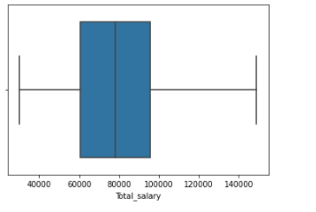

**Fig: -9**

1. **Explore all the features of the data separately by using appropriate visualizations and draw insights that can be utilized by the business.**

**Univariate Analysis of Numerical fields**

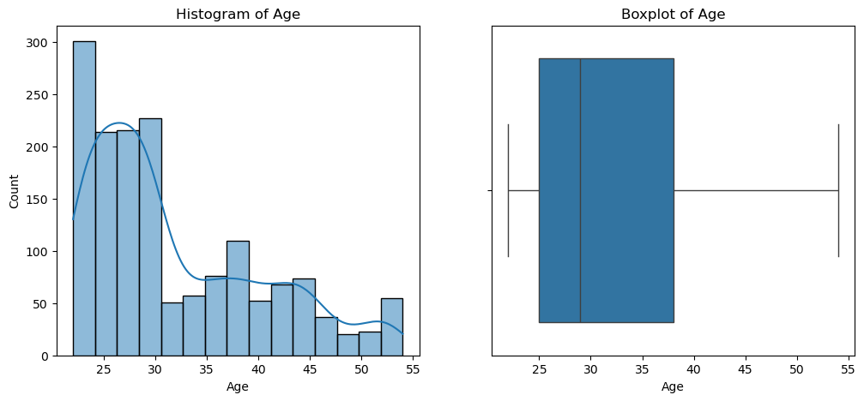

**Fig: - 10**

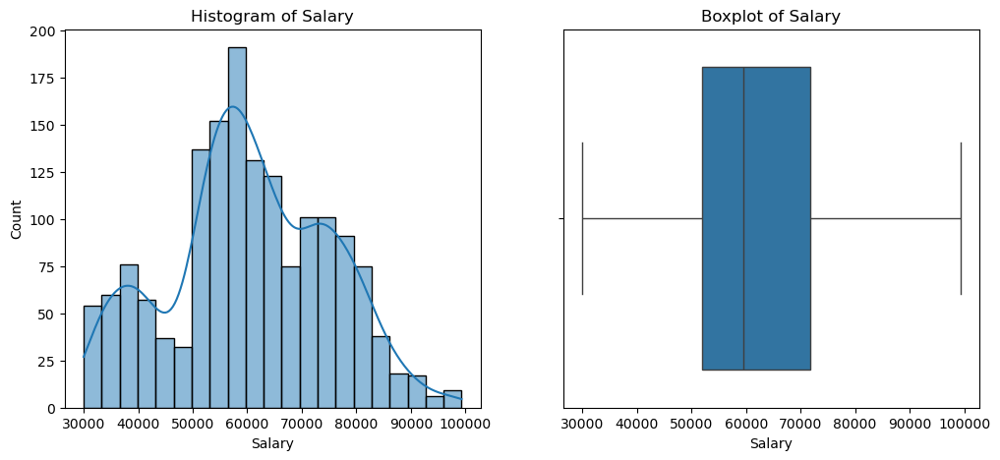

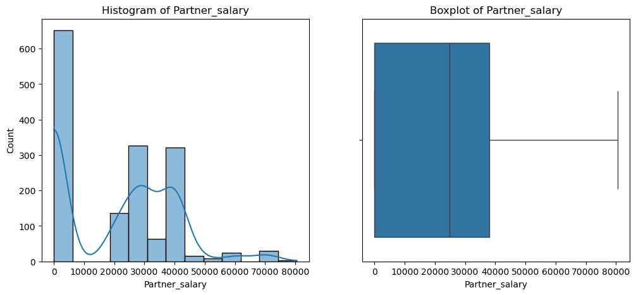

**Fig: -11**

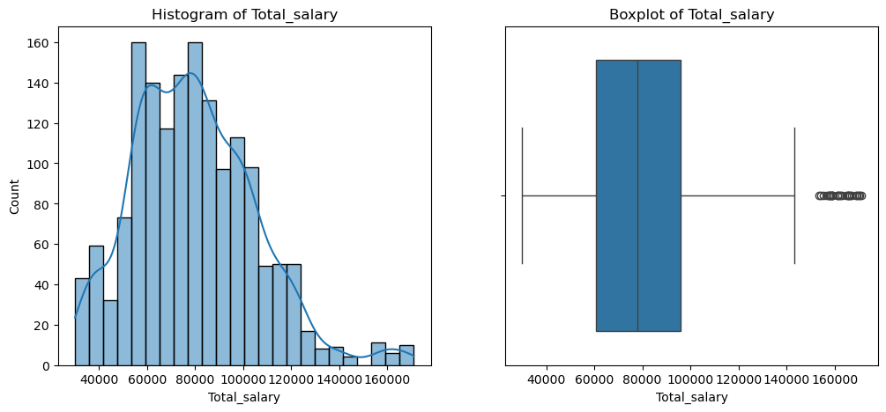 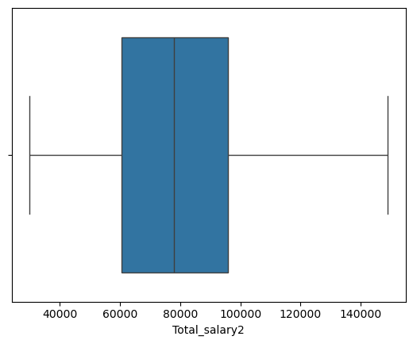

**Fig: -12**

**Univariate Analysis of Categorical fields**

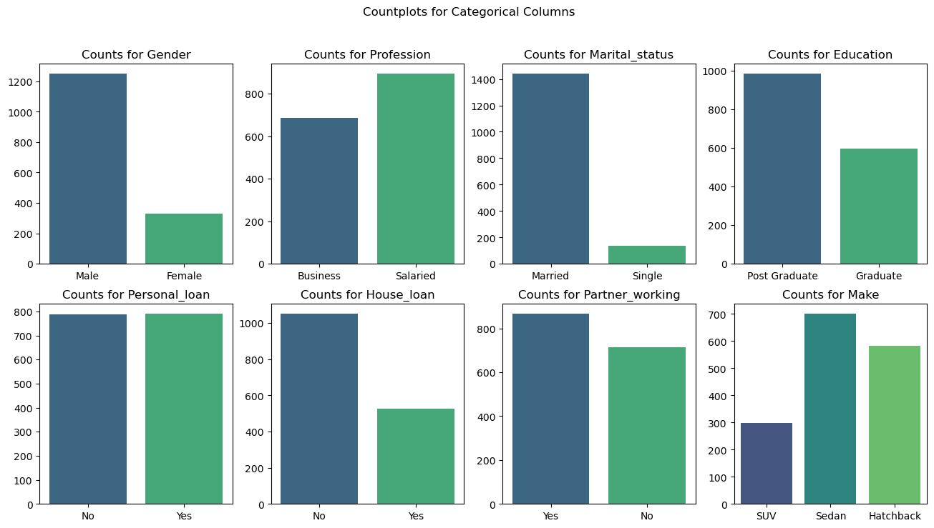

**Fig: -13**

**Inferences**

* **Majority** of the customers in the dataset are **Post Graduate**.
* **Sedan** is the **most preferred** **purchase**, followed by **Hatchback** and **SUV**
* **Salaried customer** **count** is **slightly higher** than that of **Business customers**.
* The number of **customers** having a **working partner** are **slightly higher** than customers with **non-working partner or singles**
* Most individuals do not have a **house loan.** And even **Personal loan**

**D. Understanding the relationships among the variables in the dataset is crucial for every analytical project. Perform analysis on the data fields to gain deeper insights. Comment on your understanding of the data.**

**Bivariate analysis of Numerical variables**

Pair plot on the Data set: -

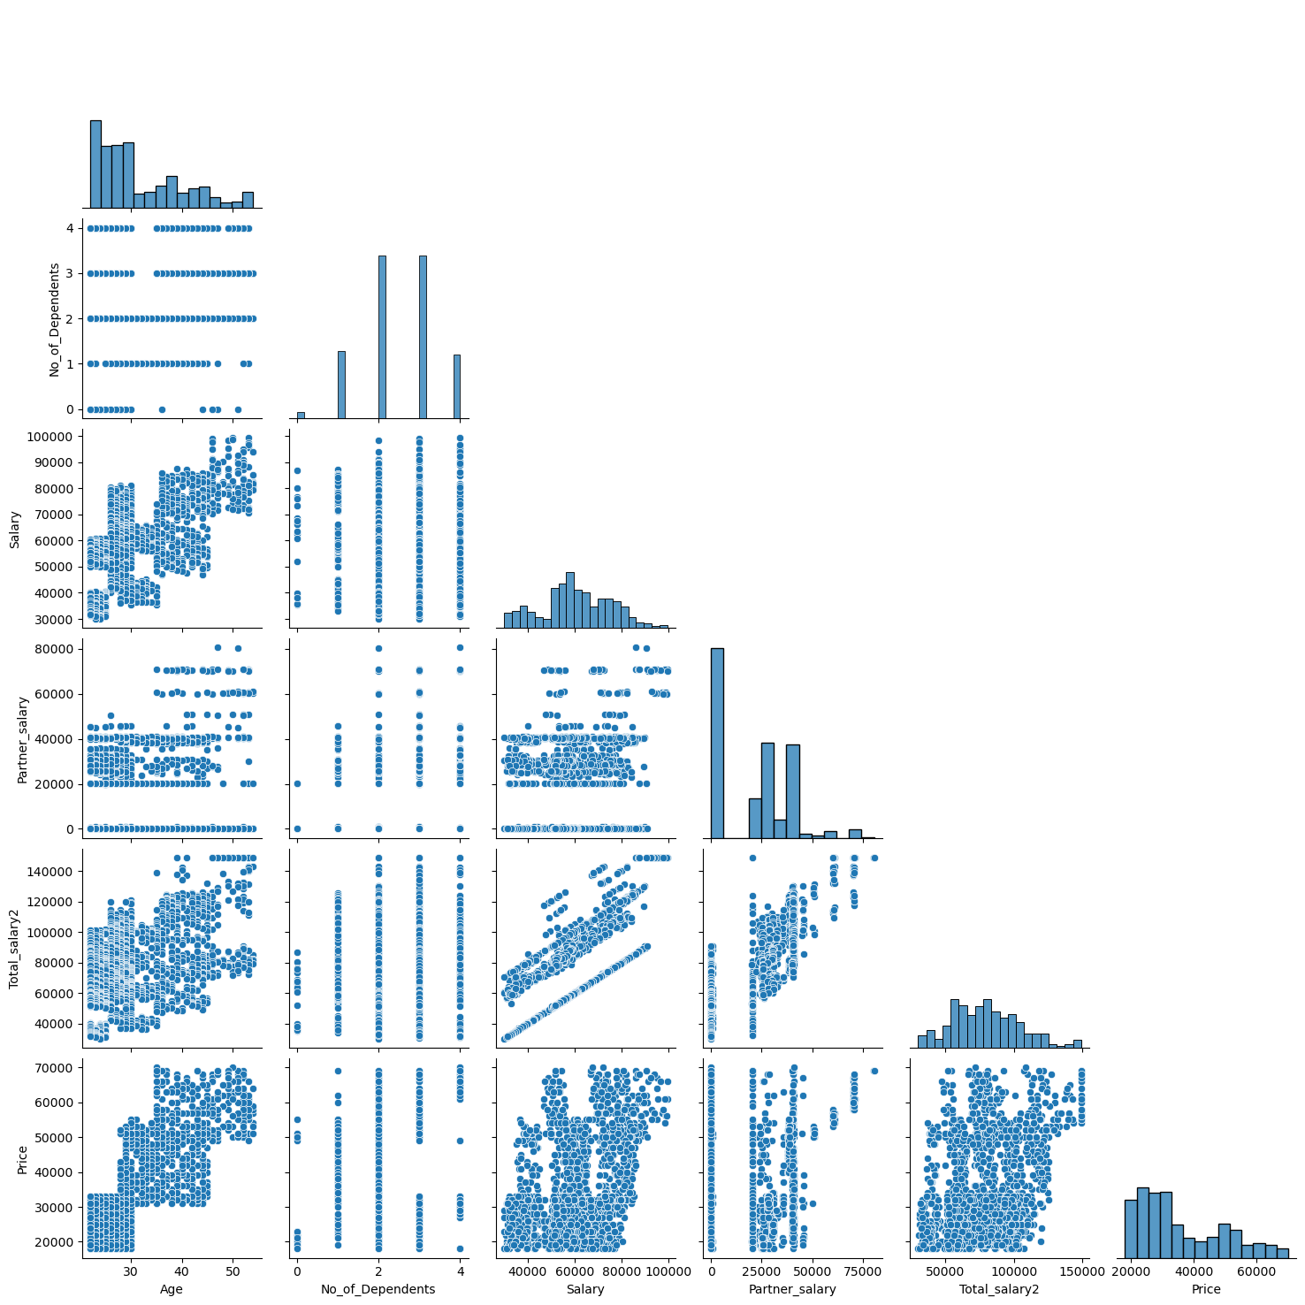

**Fig: -14**

**Fig: -15**

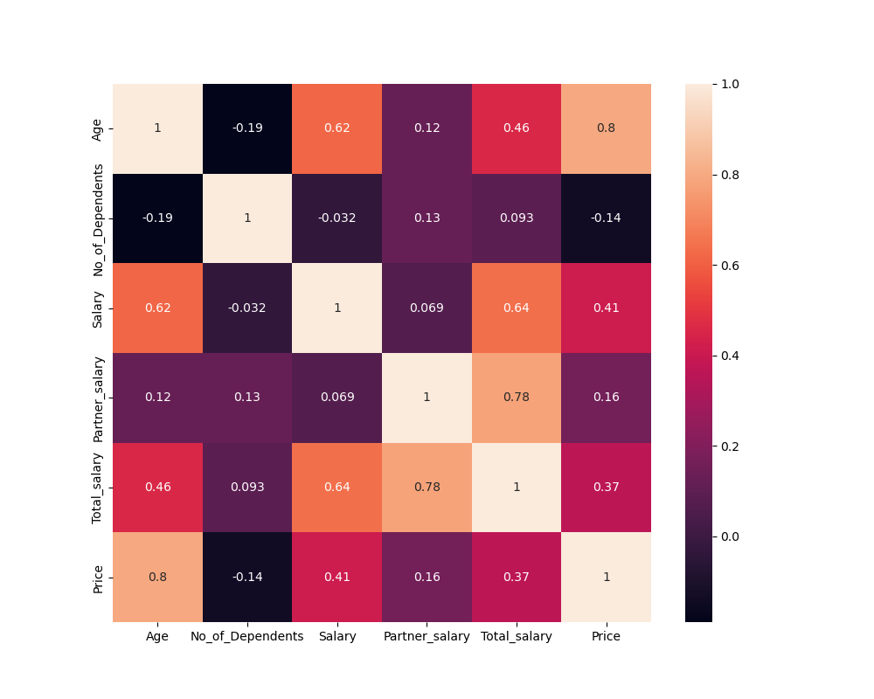

Inferences –

1. Hardly any linear relationships present among the fields.
2. **Positive correlation** between **Price and Age** is **0.8**, and **Total salary and Partner salary** has **0.78**

**Bi- Variate analysis of Categorical vs Categorical variables –**

**Inferences –**

1. The distribution of **personal loans** by gender. It shows that the majority of both **males** and **females** in the dataset do not have a personal loan. This could suggest that most individuals in the dataset either do not need or do not qualify for personal loans.
2. As we can see in the **Education** field most of the **Male** & **Female** are **Post Graduate** than the **Graduate.**
3. In the **Profession** most of the **Male** and **Female** are **Salaried** who works in IT sector, construction and automobiles sector all works in the company. As there are some **Male** and **Female** who has the **Business** field.
4. Most of the **Male** and less **Female** are having the **Personal Loan** may be some of them are not eligible to the requirement of the **Personal Loan** are may be not needed.
5. In the dataset most of them are married and there are less people who are still single.

**Fig: -16**

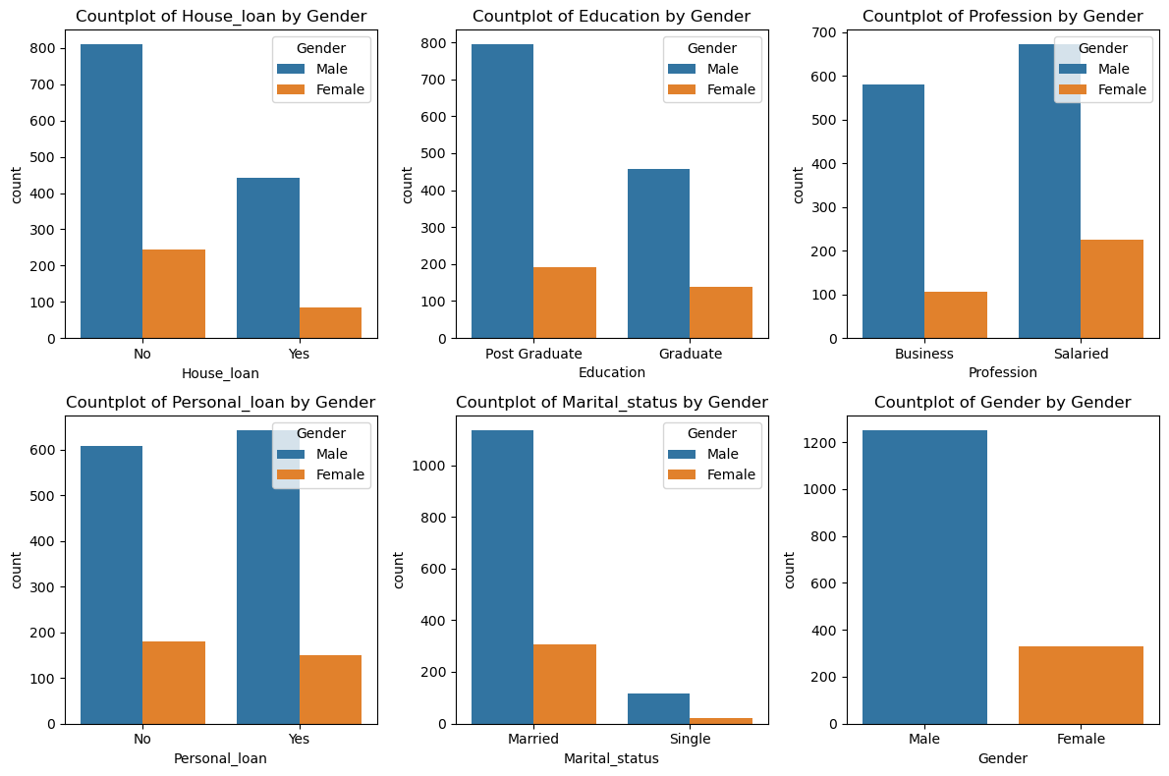

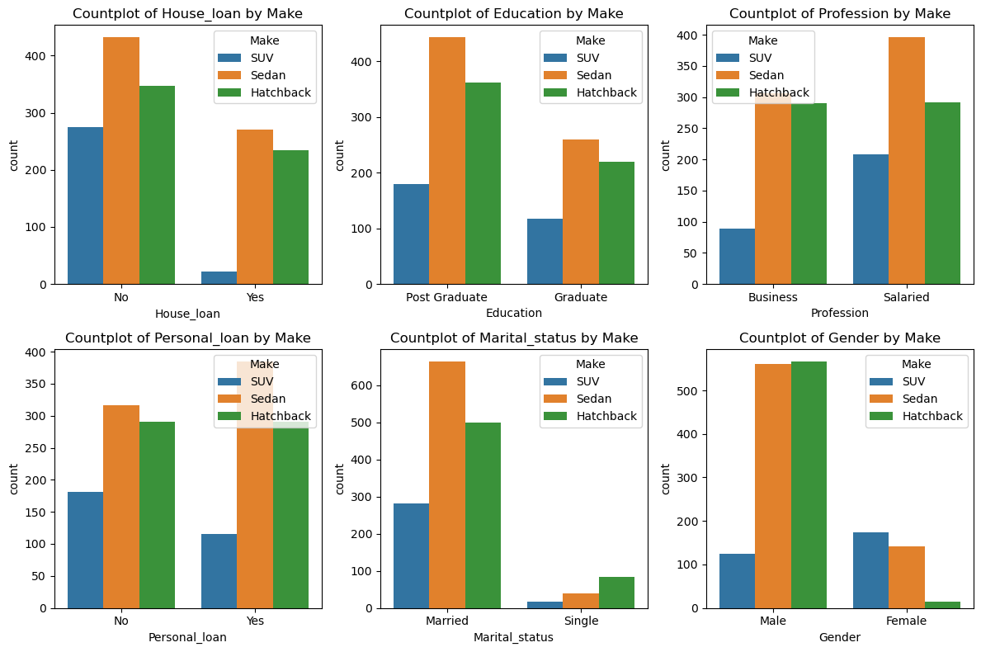

**Fig: -17**

**Inferences –**

1. Customers who have a **house loan** are **not likely to buy an SUV** (which is the costliest make among the three).
2. **Females prefer SUV** and are **least likely to buy a Hatchback**, whereas **Male prefer Sedan or hatchback**. **SUV** is **least preferable** among **males.**
3. **Married** customers **prefer Sedan** whereas **single** customers **prefer Hatchbacks**.
4. Customers who are in both Profession (Business & Salaried) they prefer Sedan and followed by Hatchback and SUV
5. Customers who have both **Personal loan** & **House loan** they prefer to buy **Sedan** than the **SUV**

* Over all we can say that **Male** prefer **Sedan** & **Hatchback** which is less affordable than the other **Make**.
* **Female** customers most preferably buy the **SUV’s** because as I assume they prefer style and comfort.
* Customers who have the loans they prefer the **sedan** over **SUV.**

**E. Employees working on the existing marketing campaign have made the following remarks. Based on the data and your analysis state whether you agree or disagree with their observations. Justify your answer Based on the data available.**

**E1) “**Do men tend to prefer SUVs more compared to women?**”**

Analyzing the ratio of SUV purchases for both the Genders, we get: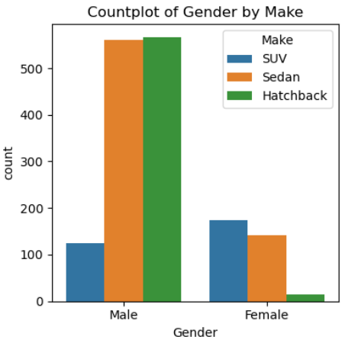

**Fig: -18**

From above data, we can **conclude** that the **Men** prefer to buy Sedan and Hatchback, because basically the **Sedan** and **Hatchback** are cheaper than the **SUV**.

**E2)** What is the likelihood of a **salaried** person buying a **Sedan**?

Analyzing the ratio of **Sedan** purchases against **profession**, we get:

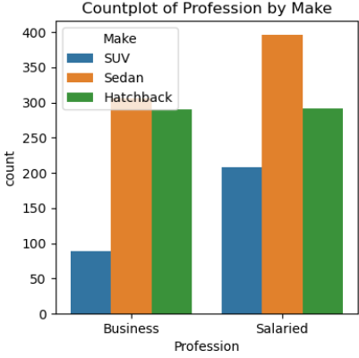

**Fig: -19**

From above data, we can **conclude** that the **Salaried** person prefers to buy the **Sedan** more than the Business Customers. Hence we can go with the Statement

**E3)** What evidence or data supports **Sheldon Cooper's claim** that a salaried male is an easier target for a **SUV** sale over a Sedan sale?

Analyzing the ratio of **SUV** purchases against **profession**, we get:

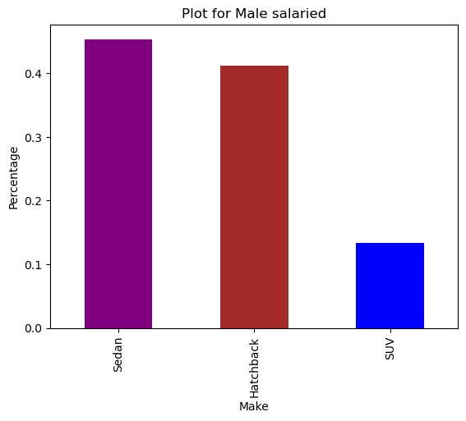

**Fig:-20**

From above data, we can **conclude** that the **statement** made by **Sheldon Cooper is Incorrect**

**E4)** How does the amount spent on purchasing automobiles vary by **Gender**?

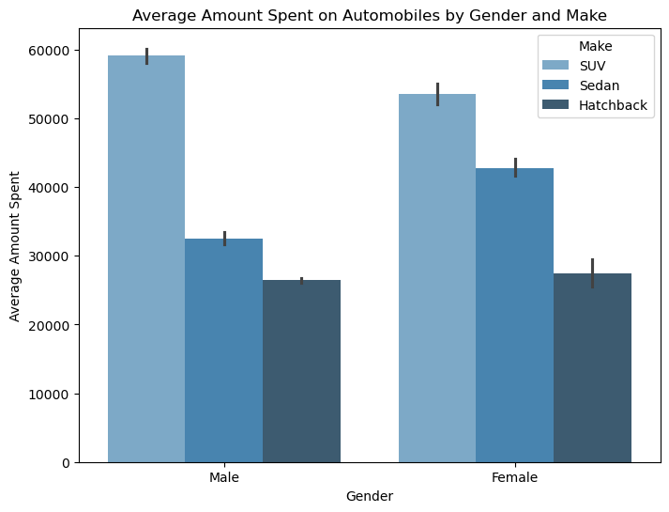

**Fig: - 21**

* From above data, we can **conclude** that **Male** spent **58K-59K** on the **SUV**,And followed by **31K-32K** on **Sedan** then on **Hatchback** they spent approximately **25K**
* As of **Female** Average amount spent on **SUV** is **55K**, on the **Sedan** they spent average amount of **42K** and on the **Hatchback** they spent approximately of **25K.**

**E5)** How much money was spent on purchasing automobiles by **individuals** who took a **personal loan**?

Total amount spent on purchasing automobiles by individuals who took a **personal loan: 34457**.

**E6)** How does having a **working partner** influence the purchase of higher-priced cars?

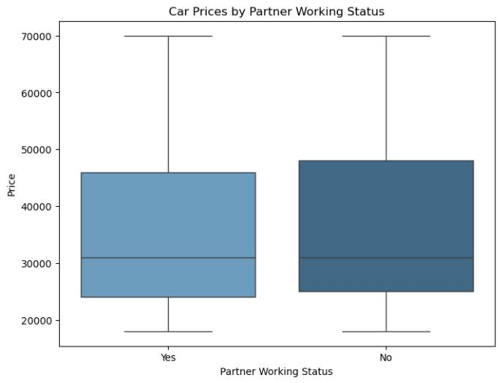

**Fig: - 22**

* From above data, we can **conclude** that it appears that when the partner is **working (‘Yes’),** the car prices show a wider range and variability compared to when the partner is not **working (‘No’**). This could suggest that individuals with **working partners** tend to purchase cars across a wider range of prices, potentially including **higher-priced cars**.
* However, the median car price (indicated by the line within each box) seems to be similar for both categories. This means that the ‘typical’ car price does not significantly differ whether the partner is working or not.
* **Mean of Price across Partner working:**
* Partner working: No = 36000
* Partner working: Yes = 35267
* **Median of Price across Partner working:**
* Partner working: No = 31000
* Partner working: Yes = 31000
* **The Mean and Median price** of the purchased automobile is **almost similar across the Partner working category**, thus indicating whether **partner is working or not,** it has **slight effect** on the **Purchase made by the customer.**

**F. From the given data, comment on the amount spent on purchasing automobiles across the following categories. Comment on how Business can utilize the results from this exercise. Give justification along with presenting metrics/charts used for arriving at the conclusions.**

**Give justification along with presenting metrics/charts used for arriving at the conclusions.**

**F1) Gender**

**Females** are more likely to buy **SUV’s** and on average spend more on cars than males **47705** Units against **32416** Units.

* Mean of Price across Gender:
* Female = 47705
* Male = 32416
* Median of Price across Gender:
* Female = 49000
* Male = 29000
* **Mean and Median** **Price** for **Female** customers is **higher than Male** **customers.**

**F2) Personal loan**

* Mean of Price across Personal Loan:
* Personal Loan: No= 36742
* Personal Loan: Yes= 34457
* Median of Price across Personal Loan:
* Personal Loan: No= 32000
* Personal Loan: Yes= 31000
* **Mean and Median of Price** for purchase made by customers **without a Personal loan** is **slightly higher** than **customers** **who have a Personal Loan**.
* **To ensure increased spend** of customers with Personal loans, the **business can look at cheaper interest rates** (for Automobile purchase) or **easy the repayment** **terms**.

**G. The main objective of this analysis is to adevise an improved marketing strategy to send targeted information to different groups of potential buyers present in the data. For the current analysis use the Gender and Marital status - fields to arrive at groups with similar purchase history.**

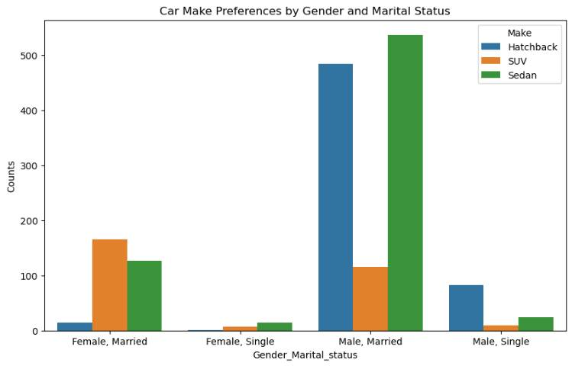

**Fig: -23**

**Most frequently purchased** Car make grouped on Marital Status and Gender, we find:

* Female – Married: SUV
* Male – Married: Sedan
* Male – Single: Hatchback
* Female – Single: Sedan

Analyzing the **mean Price of purchased car** across the Marital status and Gender, we find:

* Mean Price for purchases made by Married Females = 62857
* Mean Price for purchases made by Married Males = 60692
* **Mode** of the Car make for Gender and Marital status fields shows that **both the married groups preferring SUV**.
* Similarly, the **Mean of Price** for **Male Married is approx. 60K** while it is **62K for Female Married**.
* All the **Male Married Customers** with **Total Salary greater than 149 K** **purchased SUV**. Whereas **Married male** with **lower Total salary preferred Sedan**

**H. Actionable Insights – Business Recommendation: -**

1. Recognize Consumer Behavior: Keep an eye out for evolving consumer priorities, financial healths, plans to share, and climate change. Utilize these data-driven insights to react and adjust to changing consumer and automobile industry demands.
2. Sustainability plans: Take advantage of the chance to explore sustainability comfortness of the car make and design that the customers and less price,
3. Product Strategy and Development: Direct the development, management, and strategies of your products, including portfolio optimization and the formulation of go-to-market plans for novel technologies.
4. Keep Up with Industry Trends: Keep tabs on consumer preferences and emerging technologies that could have a major influence on the automobile sector. The Global Automotive Consumer Study by Deloitte provides insights that can assist automakers in overcoming certain obstacles,
5. Adapt to Market Disruptions: The changing market environment of the automobile sector presents many automotive firms with continual challenges, ranging from sophisticated technology to supply chain disruptions and climate change policies. Be ready to respond to these challenges with innovation and adaptation.
6. Pay Attention to Electric Vehicles (EVs): As the world moves toward sustainability, there is an increasing need for EVs. Making investments in EV development could prove to be a wise strategic choice in the future.

**(Note: some of the sentences are borrowed from the WEB regarding the technical things of Automobiles and its business field)**

**Problem-2 GODIGT Bank**

**A bank can generate revenue in a variety of ways, such as charging interest, transaction fees and financial advice. Interest charged on the capital that the bank lends out to customers has historically been the most significant method of revenue generation. The bank earns profits from the difference between the interest rates it pays on deposits and other sources of funds, and the interest rates it charges on the loans it gives out.**

**GODIGT Bank is a mid-sized private bank that deals in all kinds of banking products, such as savings accounts, current accounts, investment products, etc. among other offerings. The bank also cross-sells asset products to its existing customers through personal loans, auto loans, business loans, etc., and to do so they use various communication methods including cold calling, e-mails, recommendations on the net banking, mobile banking, etc.**

**GODIGT Bank also has a set of customers who were given credit cards based on risk policy and customer category class but due to huge competition in the credit card market, the bank is observing high attrition in credit card spending. The bank makes money only if customers spend more on credit cards. Given the attrition, the Bank wants to revisit its credit card policy and make sure that the card given to the customer is the right credit card. The bank will make a profit only through the customers that show higher intent towards a recommended credit card. (Higher intent means consumers would want to use the card and hence not be attrite.)**

**Framing An Analytics Problem - Analyze the dataset and list down the top 5 important variables, along with the business justifications.**

**- Size of Dataset**: Dataset has 8448 rows and 28 columns.

**- Data headers**: PFB the data headers present in the dataset for quick reference



**Fig: -24**

**- Dataset Information:** There are 19 numerical and 8 categorical variables. PFB the details of each: -

**Five Points Summary:**

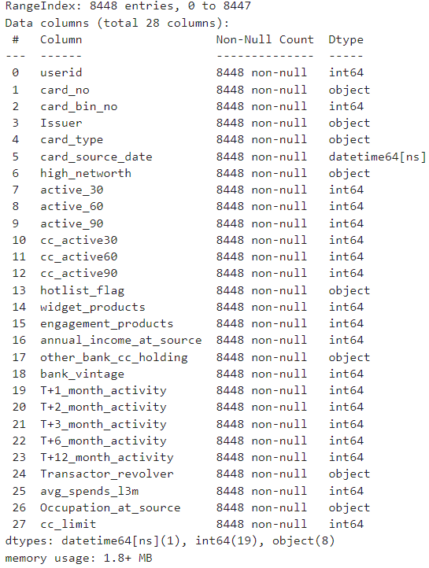

**Fig: -25**

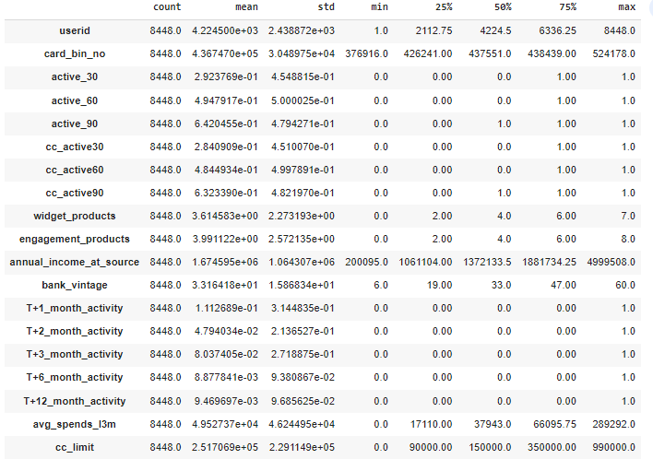

**Fig: -26**

**Exploring the data: -**

**- No duplicate values** found

- In **Transactor revolver** we found **38 null values**

**Histograph for the numerical values**

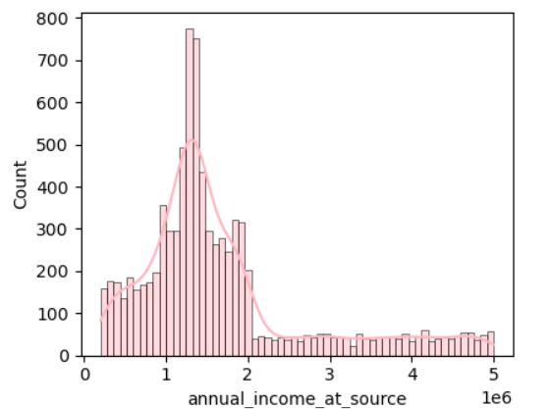 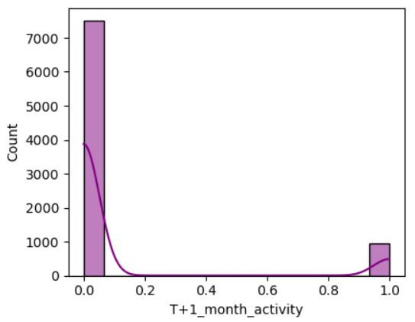

**Fig: -27**

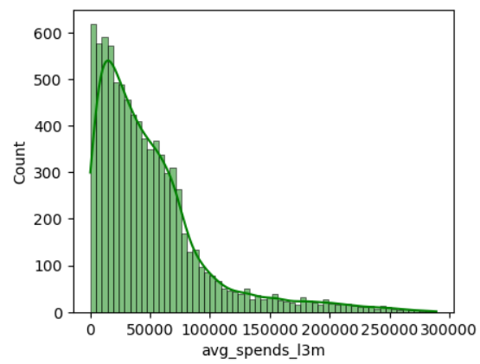 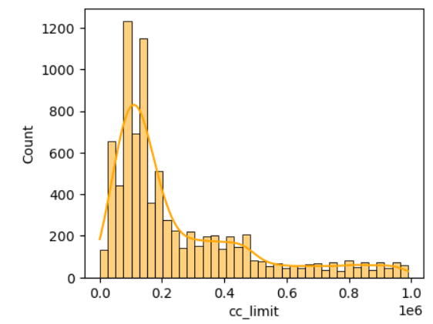

**Fig: -28**

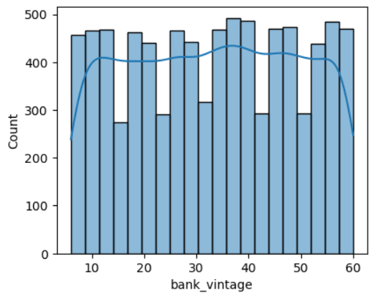 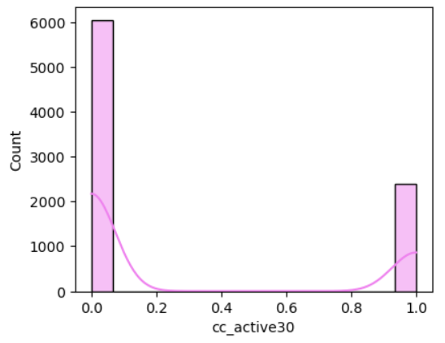

**Fig: -29**

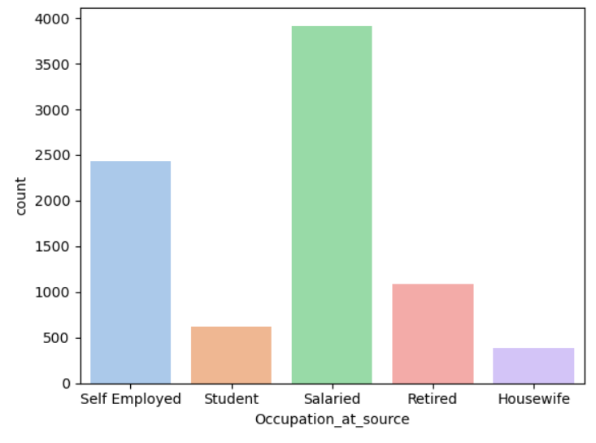 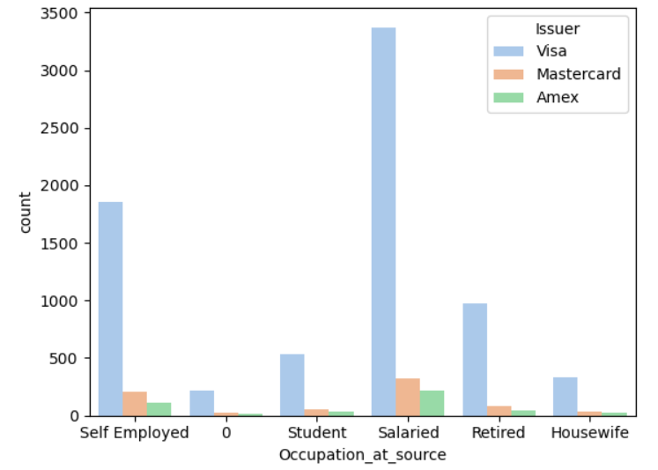

**Fig: -30**

**Below are the Top 5 important variables from the given dataset with justification.**

**1) Annual Income at source-**

Annual income plays a big role in the purchasing power of an individual hence is a vital piece of info. Income can be used by the banks to make better decisions in areas such as risk profiling, targeted ads, campaigns, offers, loan limits etc.

**2) CC limit -**

Defining Credit Card limit for customers basis their attributes (such as income, CIBIL Score, etc.) is part of the Risk Management practice wherein the banks try to minimize the number of defaulters.

**3) CC_active30 –**

Flag variables such as cc_active30, cc_active60 can be used to get an understanding over how frequently does the customer use the credit card, if the account is dormant or if the customer is experiencing any issues leading to reduced usage of the card etc.

**4) Occupation at source-**

Profession is a key factor in credit risk assessment. Salaried individuals might have a steady income stream, potentially indicating a lower credit risk compared to self-employed individuals or students. This could influence decisions related to credit limits, loan approvals, and interest rates.

**5) avg_spends_13m-**

The avg_spends_l3m variable can give important insights on the customer spending behavior. It can be used to identify whether the credit card is primary or secondary card of customer, i.e. high spend indicates primary account whereas lower spend would mean secondary account. Campaigns can be rolled out on the basis of the customer preference, customized offers can begiven to lure customers into using the credit account more frequently.

(Note: some of the sentences are borrowed from WEB regarding the banking sector etc.)

-------------------------End of Report------------------------